Description: News Entry is not displaying under the news section
Steps To reproduce :
- Open browser
- Clear the cookies / open incognito tab
- Enter the url https://osa-web.t-cg.co.uk/qatest
- Search with B16 8PE
- Scroll down the page
- Open the “Contact group “ which is in “Active state”
- News section should be opened
- Now click back and observe the page

Expected result
- News section should be opened with the news entry
Actual Result
- News entries are not displayed
- And also news section is not highlighted / user is not landed into news section page
Attachment :
Please refer the below screen shot for the reference and also please find the analysis which may help to you to fix the issue
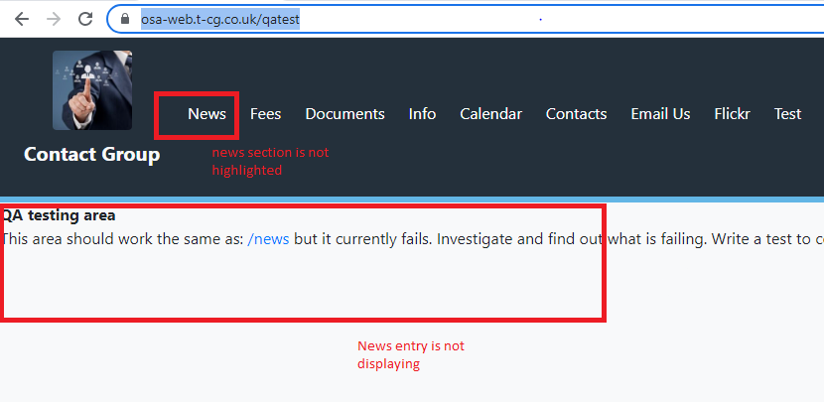

Analysis :
“ https://osa-web.t-cg.co.uk/qatest “ page is returning 404 response code.

Steps :
- Right click on the page
- Choose inspect
- Goto network
- Now reload the webpage
- Now you can able to see the 404 response
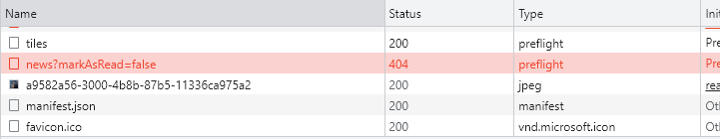

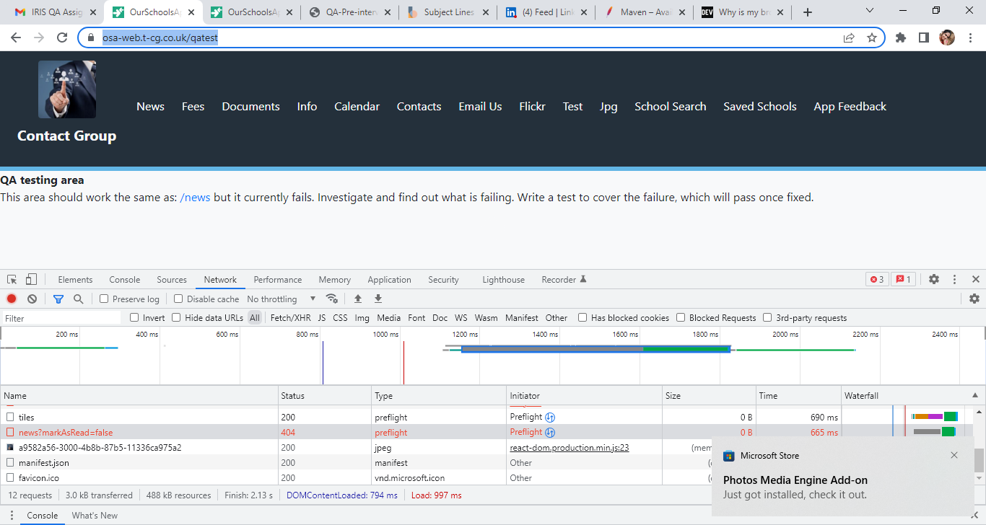

Means the api https://pro-fapi-osa.t-cg.co.uk/api/schools/organisationId/news?markAsRead=false is giving 404 so response is not loading here. please find the below screenshot for reference
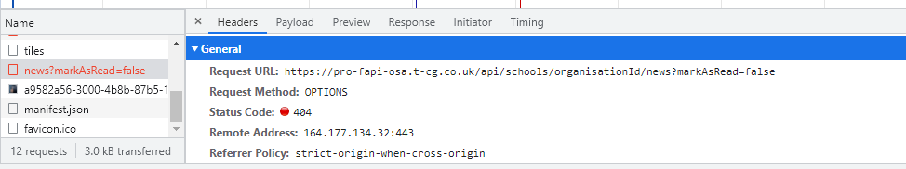
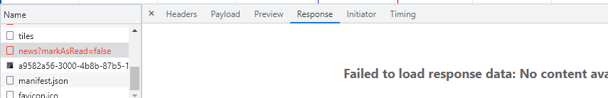
Note :
- When we are comparing this https://osa-web.t-cg.co.uk/qatest with the https://osa-web.t-cg.co.uk/ we can find out that in this page all apis are returning 200 staus code
- And also when we observe the https://pro-fapi-osa.t-cg.co.uk/api/schools/organisationId/news?markAsRead=false (api ) organisationId is missed which is displaying in the prod url (“https://osa-web.t-cg.co.uk/”)

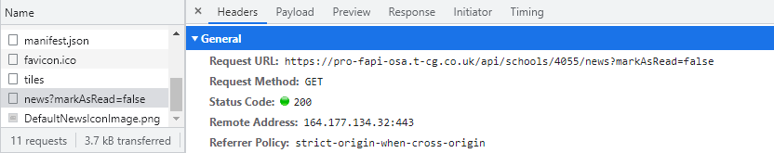
Organization id
